**MANAV RACHNA INTERNATIONAL INSTITUTE OF RESEARCH AND STUDIES**  
(Deemed to be University under section 3 of the UGC Act 1956)  
School of Computer Applications

**Data Mining file**

**Bhavnish koli**

**23/SCA/BSC.IT/002**

1. Demonstration of preprocessing on dataset employee.arff

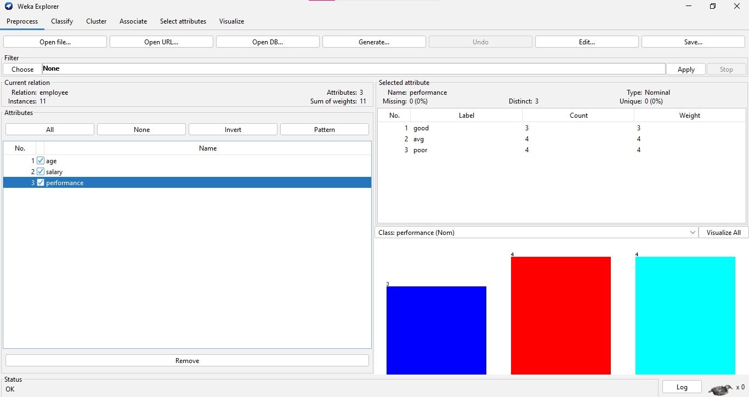

2.Demonstration of preprocessing on dataset employee.arff

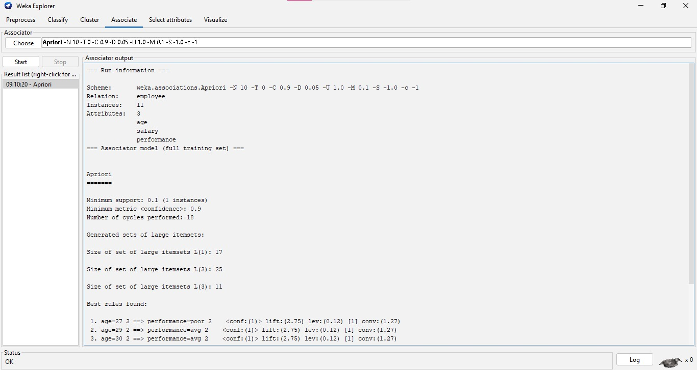

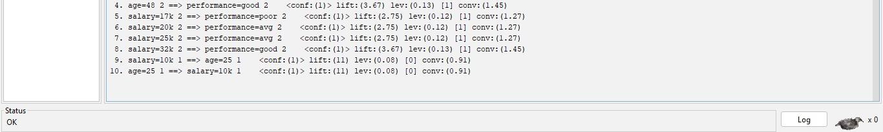

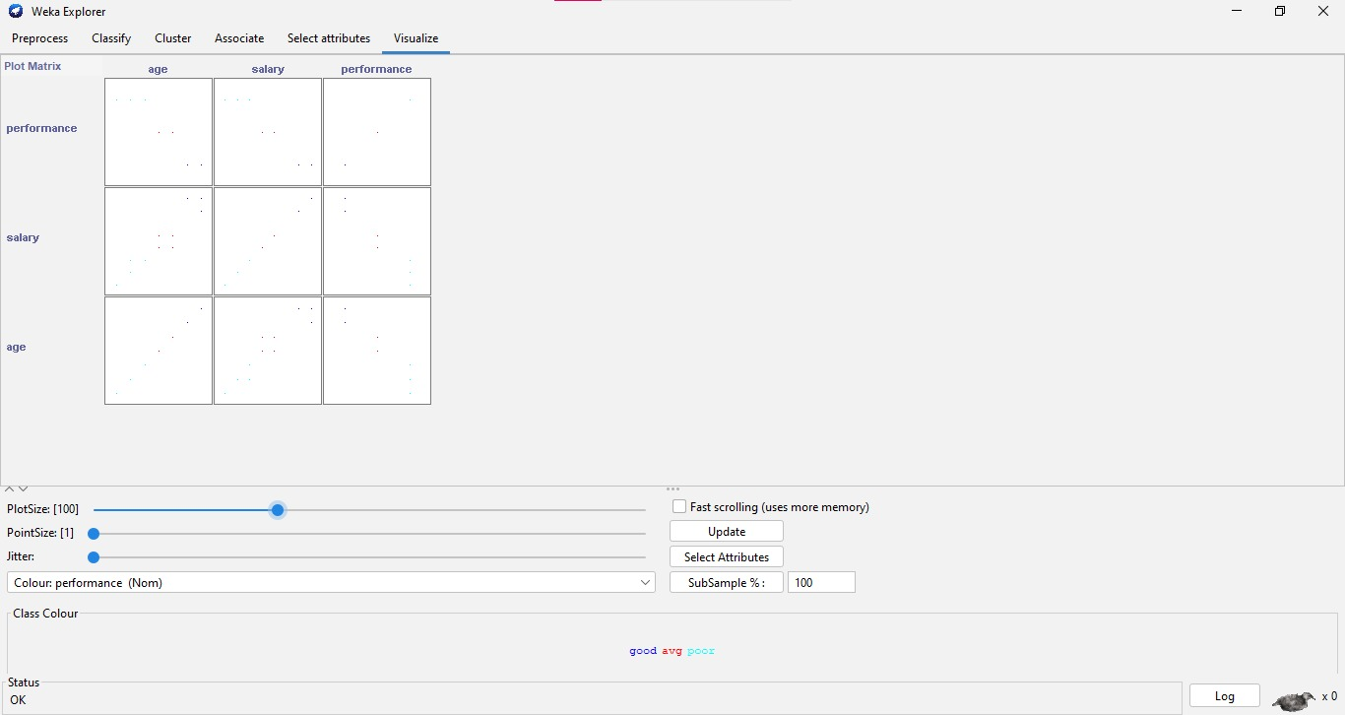

3. Demonstration of classification rule

process on dataset employee.arff using naïve Bayes algorithm

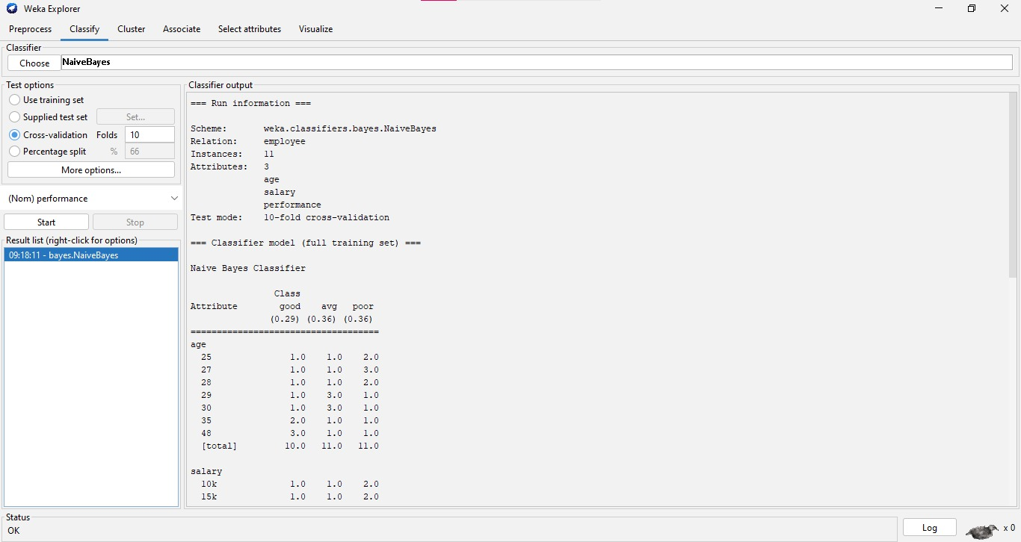

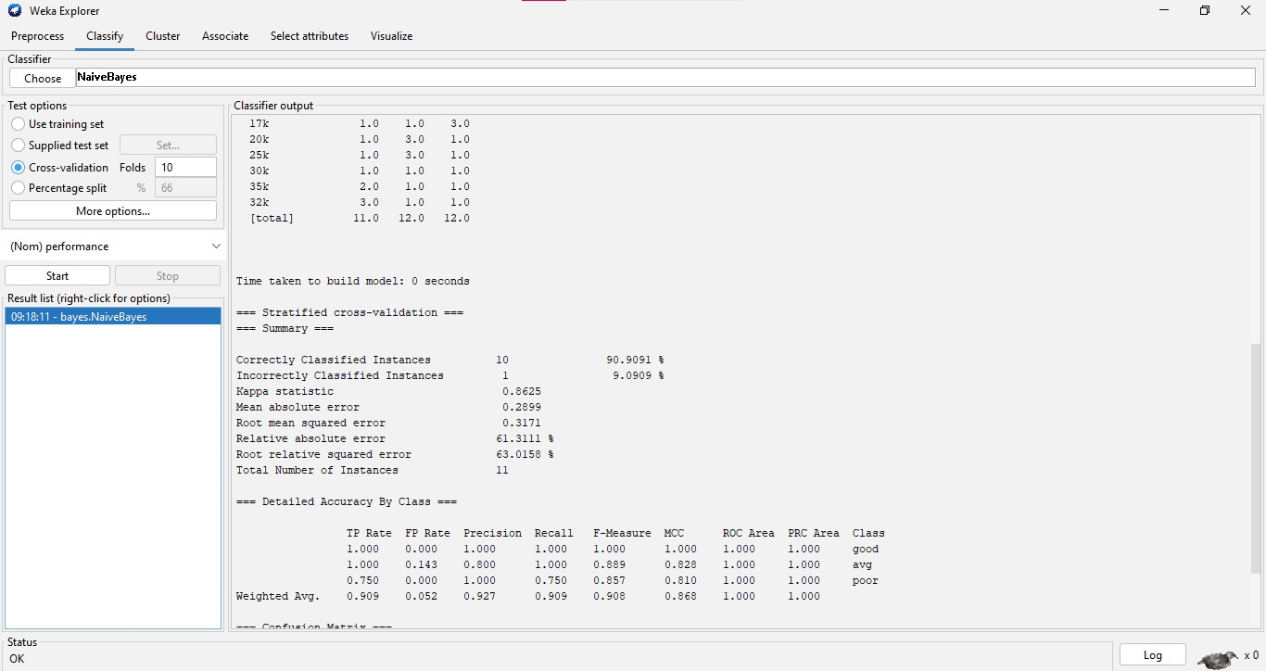

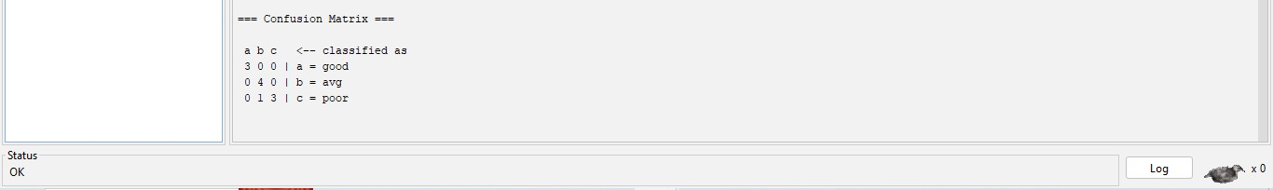

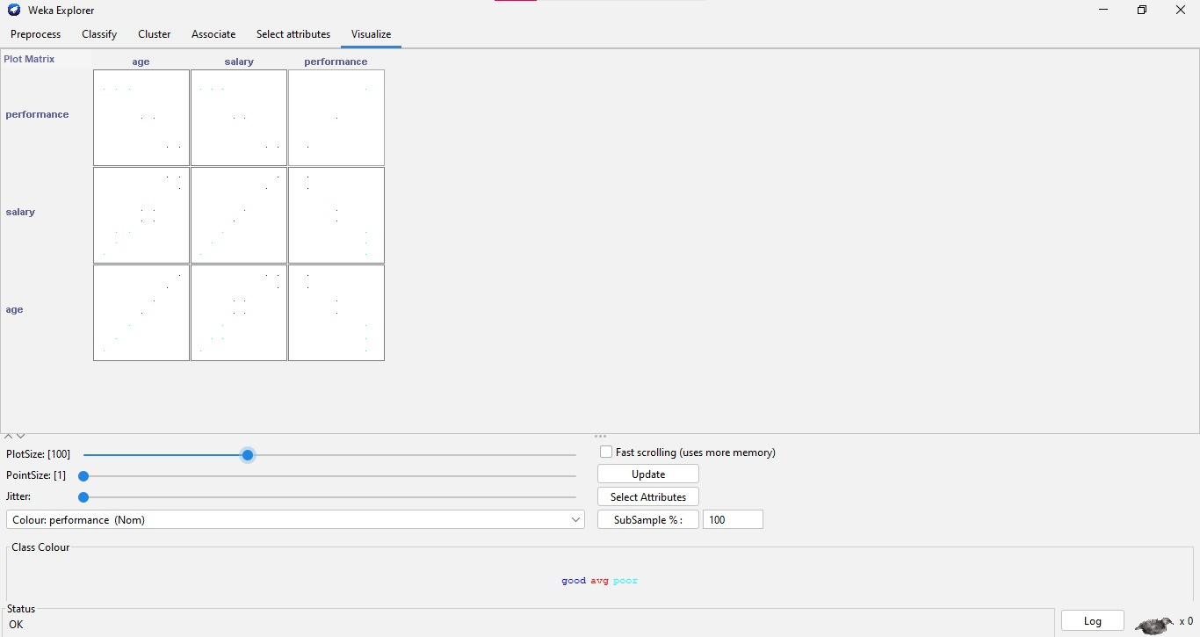

4. Demonstration of clustering rule process

on dataset Employee.arff using simple k- means

